ON- AND OFF-RESERVATION LIFE:
A REEXAMINATION OF CROW-FLIES-HIGH VILLAGE

Rachel Thimmig

ABSTRACT
The primary settler-colonial period on the Plains, the Reservation Period (1850s-present), receives far less attention than early contact and Fur Trade sites. The archaeology that has been done comes from government-sponsored salvage excavations conducted in the 1940s and 1950s. One such site, Crow-Flies-High Village (32MZ1), occupied between 1884-1893, was the second locale of the Crow-Flies-High band that resisted reservation life for over two decades. Carling Malouf’s salvage excavation of this site uncovered rectangular cabins and an abundance of “White” objects with “little of Native origin,” which led to his conclusion of a loss of Indigenous identity. This research critiques the salvage archaeology done during the River Basin Surveys and reexamines the Crow-Flies-High Village materials through the lens of contemporary theoretical developments such as survivance, residence, practice, memory, and futurity to provide a more comprehensive and complex understanding of the Mandan, Hidatsa, and Arikara experience.
INTRODUCTION
Research Problem:
The salvage archaeology project known as the River Basin Surveys contributed to an increased interest in the historical archaeology of the Plains (Lees 2014). However, the excavations, reports, and uncritical admiration for the archaeological analysis produced contribute to the ongoing legacy of the United States colonial endeavor. In this paper I argue this is due to a failure to consider settler colonialisms effects on the lives of Indigenous peoples who lived at these sites and a failure to treat the River Basin Survey reports themselves as historical documents and products of a settler colonial government. This research will consider both, situating the salvage archaeology done in the Garrison Reservoir area within the framework of settler colonialism and offering a reexamination of the excavated materials from Crow-Flies-High Village (32MZ1), excavated in 1952 by Carling Malouf. The critique of salvage archaeology and its acculturative approach will be exemplified by my reanalysis of the artifacts using contemporary theoretical concepts in historical archaeology, settler colonial studies, and Indigenous studies.
Plains Archaeologists’ Reflections on the River Basin Surveys
Much of the literature on the connection between the River Basin Surveys and Plains historical archaeology, even that which was produced recently, never mentions the words ‘settler colonialism.’ It does, however, situate the reports as historical documents, which they are, since many are over fifty years old. Despite this, the outdated findings are dismissed as products of their time (see Lees in Banks and Czaplicki 2014). Some go so far as to argue that it is “unfair” to “complain that those working then did not share current predispositions” (Lees 2014:161). I disagree, instead, what is unfair, especially to descendent communities, is that after accepting the fact that the reports are problematic, archaeologists continue to leave them as undisputed canon foundational to present work.
This is incredibly true for later historic sites, which were not given proper attention then and are still not afforded much research value now. For example, archaeology’s contribution to the canon of Crow-Flies-High Village (32MZ1), is underexplained and dismissive. For over fifty years, the River Basin Survey 1963 report was the only study focused on the site and its community. Thankfully, Michael Barthelemy Jr., a descendent of the Crow-Flies-High community, added his 2016 oral history Master’s thesis to the literature (Barthelemy 2016). It directly challenges many of the 1963 report’s findings. Most notably, Barthelemy argues for a continuance of Indigenous religious and cultural practice whereas Malouf argues for their absence, using what he identifies as Euro-American objects as proof (Barthelemy 2016; Malouf 1963).
Barthelemy’s conclusions demonstrate how oral histories and Indigenous knowledge add complexity and nuance to stories that have previously been flattened by historians and archaeologists. I view a reexamination of Malouf’s excavated materials along the same lines: the use of contemporary theory regarding concepts such as Native survivance, residence, practice, memory, and futurity within the framework of settler colonialism can only provide more complexity and nuance. Furthermore, since these objects are the only materials that remain, we, as Plains archaeologists in the 21st century, continue the harm done by the Garrison Dam when we leave these problematic representations of the past as our contribution to Mandan, Hidatsa, and Arikara culture history. The importance of our contributions is beautifully summed up in the words of Gerard Baker:
“We look at that archaeological work today and understand that those excavations are part of our history and the tribal members born after the dam see these reports as a partial view into our past, one that will be complete with the addition of our oral history.” (Baker 2014:204)
In this instance it is the opposite, the oral history has provided a more complete history than the previous archaeology, but now is the opportunity to amend the information archaeology offers and move toward a more complete understanding of the past. But before I begin, I must provide some background for not only the site, but also salvage archaeology on the northern Plains

BACKGROUND
Mid-to-Late Nineteenth Century Mandan, Hidatsa, and Arikara Life
In 1845, the Hidatsa and Mandan left the Knife River region due to external hardships including smallpox, unceasing raids, a lack of timber, scarce game, and the shifting of fur trade interests northwest (Hollenback 2012). They jointly established Mua-Iruckphe-Hisha-Adiish, Like-A-Fishhook Village (32ML2), near Fort James, later known as Fort Berthold (Gilman and Schneider 1987; Smith 1972).
Around 1860-1861, the Arikara abandoned their village, which was originally established by the Mandan called Mitu'tahakto's, meaning First Village or East Village, but known to archaeologists as Fort Clark (32ME2), and established Star Village (32ME16) directly across the river from Like-A-Fishhook (Gilman and Schneider 1987; Metcalf 1963). They moved into Like-A-Fishhook the following year after an attack by the Lakota, specifically the Hunkpapa and Oglala (Barthelemy 2016:42; Gilman and Schneider 1987; Metcalf 1963). The result was a settlement comprised of three tribal entities and their subgroups. Though culturally similar, each had distinct identities which created a complicated social environment that was exacerbated by a number of changes to village life. The two most important were decreased mobility and increased government involvement.
Prior to the 1860s, for the most part, the Hidatsa and Mandan wintered in separate winter villages, but in 1866, Like-A-Fishhook became a year-round settlement (Gilman and Schneider 1987; Smith 1972). The relentless Lakota and Dakota raids prompted the arrival of the military in 1864 and their permanent residence at Fort Berthold II in 1867, marking the beginning of overt government paternalism (Smith 1972). Finally, the establishment of the Office of Indian Affairs agency at Fort Berthold II in 1868 led to even greater supervision and governmental control of payments, land rights, and rations (Smith 1972). In 1870, President Ulysses S. Grant signed an executive order establishing the Fort Berthold Indian Reservation, with land holdings significantly smaller than those outlined in the 1851 Treaty of Fort Laramie (Felter 1972:30; Senate Committee on Indian Affairs 1870:883). Henceforth the reservation impacted daily life more than ever before.
As these external events unfolded, internally, traditional Hidatsa and Mandan forms of leadership were at odds. Among the Hidatsa-proper and Awaxawi the owner of the Earthnaming Bundle is the civil leader and peacekeeper with the authority to decide their second in command as war leader (Barthelemy 2016:50). However, when the Hidatsa consolidated, two Earthnaming bundles were present at Like-A-Fishhook: one owned by the older Poor Wolf (Awaxawi) and the other by the younger Bobtail Bull (Hidatsa-proper) (Barthelemy 2016:50-51). In addition to multiple bundles, the Hidatsa-proper had been moving away from formalized bundle rites for some time, and instead, were making personal bundles from vision quests and hosting elders rather than paying for rites (Barthelemy 2016:47-48). Crow-Flies-High was one such Hidatsa-proper man who had made his own personal bundle, and despite being young, not having paid proper dues, and not having acquired proper credibility to lead, Bobtail Bull appointed him as war leader (Barthelemy 2016:49-51). This led to a split amongst the three Hidatsa subgroups and the two Mandan Nuptadi and Nuitadi subgroups (Barthelemy 2016:53). The Nuitadi Mandan preferred Poor Wolf, because he also owned the rights to one of their Corn Ceremony Bundles, a bundle of similar importance to the Earthnaming Bundle (Barthelemy 2016:51).
The situation reached a breaking point when Crow-Flies-High publicly accused Poor Wolf and his war leader, Paunch, of giving unequal shares of meat rations to members of their faction (Barthelemy 2016:54). Due to Crow-Flies-High’s blatant disregard for age-grade norms, there was a plan to assassinate him, but before an attempt was made, Bobtail Bull and Crow-Flies-High left with between 120 to 140 Hidatsa-proper, Nuitadi Mandan who were similarly disrespected by the Nuptadi, and disillusioned Awatixa and Awaxawi (Barthemely 2016:54, 56).
This incredibly simplified version of the intricate backstory is necessary to establish the important factors which drove Crow-Flies-High and his followers away from reservation life—limitations on mobility, increased government oversight, and differing religious understandings—all of which played a continuous role in the group’s decisions, especially at their second settlement.
Settlements Established by Crow-Flies-High
Before settling at Crow-Flies-High Village, or better known as Hushgah-eeda-Adiish, Stream of the Badlands Band, (Barthelemy 2016:86) the group settled near the confluence of the Yellowstone and Missouri Rivers in close proximity to Fort Buford (Barthelemy 2016; Fox 1988). This first settlement is known to archaeologists as Garden Coulee (32WI18) and to descendants as Hushgah-Adiish, Badlands Lodge or Badlands Village (Barthelemy 2016:57). Little is known about the relationship between the sites besides the fact that Garden Coulee was occupied between 1868-1884 and Crow-Flies-High Village from 1884-1893 (Barthelemy 2016:2; Fox 1988; Malouf 1963).
Gregory Fox excavated and conducted geophysical investigations at Garden Coulee in the 1980s and published his 1988 Master’s thesis on the site (Fox 1988). The site falls within the National Parks Service’s land at Fort Union, and the collections are housed there. The site’s materials were not reviewed for this project, mainly due to time constraints and accessibility issues, but the site is said to have had twenty-three earthlodges and seven log cabins, housing around one-hundred-fifty people consistently throughout the village’s history (Barthelemy 2016:71).
Fort Buford was an important military location during the Great Sioux War, and the community’s proximity prompted the officials to hire men as couriers (Barthelemy 2016:85). After the surrender of Sitting Bull at Fort Buford in 1881, all Plains tribes were confined to reservations, except the followers of Crow-Flies-High (Barthelemy 2016:86). They were eventually pressured by the military to leave the Fort Buford area in 1884, and subsequently moved to establish Crow-Flies-High Village near the mouth of the Little Knife River (Barthelemy 2016:87). Barthelemy suggests the Crow-Flies-High Village site’s gardens were farmed by women while the group still lived at Garden Coulee, and that Garden Coulee was a winter encampment for hunting and eagle trapping (Barthelemy 2016:87). This paper does not analyze the complex relationship between the two sites, but hopefully, research on this topic will be done in the future.
Salvage Archaeology on the Plains
The extensive salvage archaeology project known as the River Basin Surveys were conducted between 1946-1949 after the 1944 Flood Control Act authorized the implementation of the Pick-Sloan Plan (Govaerts 2016). The Garrison Dam in North Dakota was to be the first major construction project (Govaerts 2016). The dam was constructed without prior consultation and without the consent of the Mandan, Hidatsa, and Arikara population living within the flood zone on the Fort Berthold Reservation (Govaerts 2016). The lack of consultation combined with the forced relocation of the majority of the population, the abandonment of the primary settlements in the area, and the inundation of sacred sites and landmarks has left the community with significant trauma of loss and grief which they still deal with to this day (Baker 2014; Govaerts 2016; Murray et al. 2011; Murray and Kroupa 2018).
Archaeologists also feel as though they have suffered a loss (Banks et al. 2011). Surveys indicate that within the Garrison Reservoir area alone, there were over one-hundred-fifty archaeological sites, the majority of which were associated with the Mandan and Hidatsa (Govaerts 2016). Unfortunately, only a handful of these sites were given full excavations, later reported in River Basin Surveys’ Papers No. 19-20, 26-29, and in separate National Park Service publications (Govaerts 2016; see tDAR, Lehmer 1971, and Smith 1972). Crow-Flies-High Village was one such site, surveyed in 1947 by the River Basin Survey team, and later excavated by Carling Malouf in 1952 (Malouf 1963).
After the inundation of these sites, it was concluded “that the Garrison region was mainly an area of hunting camps and other temporary settlements, with very few permanent villages,” and that “the lower Garrison region was a refuge area for the village tribes during the last years of their long history” (Lehmer 1971:38-39). These statements indicate a disconnect between the archaeological and ethnographic records; the former, even after consulting the latter, argues for complete assimilation and a loss of Native culture (Lehmer 1971; Malouf 1963; Smith 1972).
Additionally, the complete lack of acknowledgement on how archaeology is connected to this unimaginable loss, especially how archaeology enabled the implementation of the Pick Sloan Plan, continues to this day. Until very recently, the cost of dam construction has been evaluated from the point of view of the archaeologists, not the Indigenous community. When they were included, it was minimal. For example, in a 2011 article, archaeologists emphasize the economic cost of mitigation and the cost to Middle Missouri archaeology, leaving just three paragraphs devoted to “social impacts” (Banks et al. 2011:82). The single sentence acknowledging “the impact on the tribes of the destruction of ancestral sites reaches far beyond the destruction of sites and the loss of data,” is vastly overshadowed by the article’s main concern for the losses archaeologists experienced (Banks et al. 2011:382).
Somewhere along the way, archaeologists working on Plains historical archaeology have decentered humans in their research. This has led to a continuing failure to consider the complex ways the humans whose material cultures they study navigated a settler colonial world. Furthermore, archaeologists have also failed to address their own positionality; they too are humans, with their own sets of biases, still operating within a settler colonial nation that continues to dispossess Indigenous communities of their lands and cultural heritage. There is an incredibly important intersectionality that must be explored if we are to decolonize methodologies and theories moving forward.
THEORY AND METHODOLOGY
The United States as a Settler Colonial Nation
When most Americans think of settler colonialism or the colonial period, they think of the original thirteen colonies and the revolution against the British. It is true that the British started the process of settler colonialism on the east coast, but the United States continued and perfected British practices of dispossession as the nation fulfilled its Manifest Destiny. The current definitions established by settler colonial studies illustrate this.
To begin, settler colonialism differs from traditional colonialism primarily in how their main objectives lead to different treatments of an area’s Native inhabitants. The goal of settler colonialism is to erase the distinction between the colony and its source (Veracini 2011:4). Ultimately, settler colonialists aim to establish settlements that are indistinguishable socially from those in the home country (Veracini 2011). Successful settler colonies tame unruly wildernesses, become their own independent nations, destroy alternative Indigenous worlds, and manage ethnic diversity (Veracini 2011:3). These objectives are accomplished through the dispossession of Indigenous land and Indigenous peoples.
This is the trajectory the United States has followed. Although pockets of the United States do not fit exactly within a settler colonial framework such as this, major trends over time lean toward settler colonialism (Olster 2019). Ultimately, the United States of America is a semi-successful (I say semi because it failed to completely extinguish Indigenous peoples) settler colony turned colonial power that should be studied as such (Olster 2019; Veracini 2011).
It is therefore no surprise that anthropology and archaeology in the United States are deeply tied to colonialism. For example, in the beginnings of anthropology as a discipline, the encounter was almost always colonial, with the anthropologist belonging to the dominant colonizer group and their subjects belonging to the dominated colonized group (Asad 1979). Therefore, any and every interaction was tinged with inequalities that were often ignored. The inequalities began with actors' experiences, which were unevenly recorded, creating sources that privileged some and silenced others (Trouillot 1995). Oftentimes, what the anthropologist recorded and what they considered legitimate sources of knowledge privileged colonial objectives and Western ideals (Simpson 2007, 2018).
Salvage ethnographies were a prime example of this. They were motivated by the "settler notion of the inevitable, incontrovertible disappearance of Native people," which was necessary if the United States was to maintain its claim to the land (Simpson 2018:175). Despite this intersection, American salvage anthropologists and later salvage archaeologists separated the settler state from their studies and claimed to focus on what was being lost: culture (Simpson 2018). In reality, culture was not the only resource being lost by Native peoples; land was equally important (Simpson 2018). Moreover, there was a failure to consider Native peoples as part of the colonial system in which they lived, besides the idea that assimilation was rapidly destroying their culture (Asad 1979; Simpson 2007, 2018). It was unthinkable that Indigenous peoples could retain their lands, cultural practices, knowledge, and language with the influx of non-Native goods, Euro-American style farming and architecture, and government paternalism. The only possible options were to stay the same or change and staying the same had failed thus far in the eyes of anthropologists and the United States government. The very act of ‘salvaging’ culture depended on culture disappearing, suggesting assimilation and the dispossession of Indigenous land for settler use was both inevitable and successful.
Just like salvage anthropology, the salvage archaeology done in the 1950s cannot be separated from the settler colonial society of the United States. First and foremost, the River Basin Survey program was a federal program, run by the Smithsonian Institution, which has deep ties to the systematic study of Native peoples in an attempt to strategize proper ways of governance (Simpson 2007; see also Smithsonian’s website), and the National Parks Service, which has its roots in the sectioning off of lands, many of which were significant to Native identity, for the enjoyment of White Americans. The interactions were also primarily colonial—the majority of archaeologists were White men, and the majority of the sites to be destroyed were Native sites.
Finally, situating the River Basin Surveys within larger trends in federal Indian policy further emphasizes the colonial undertones. For instance, the Truman administration ushered in the Termination Period with the passage of the Indian Claims Commission Bill in 1946 and the Zimmerman Plan in 1947, both shared the goals of assimilating Native Americans into mainstream society and decreasing the federal government’s financial burden (Fixico 1990:29-33). These policies reduced the Department of the Interiors budget for the Bureau of Indian Affairs by half, which cut funding to reservation schools, hospitals, and other basic infrastructure, under the assumption tribes will become self-sufficient from money made via the Claims Commission (Fixico 1990:35). In reality, this led to a loss of land, as many individuals were forced to sell due to dire economic circumstances (Fixico 1990).
It has been described as a repeat of the assimilationist policies of the late 19th century that prompted salvage anthropology (Fixico 1990). This new period of land loss prompted archaeologists to salvage what material culture they could, assuming these tribes would soon be modernized Americans. Additionally, the 1940s and 1950s went beyond simple settler encroachment, they combined with the purposeful destruction of land that ultimately benefitted the settlers.
In summary, the River Basin Surveys and salvage archaeology in general support the settler colonial model of dispossessing Indigenous inhabitants of their land. Therefore, it is imperative that all subfields of anthropology operating within the United States consider the ongoing effects of American settler colonialism in their analysis. That being said, an overly pessimistic view of settler colonialism reduces past human agency, so there is a thin line all anthropologists must walk between ignoring and focusing too much on negative settler colonial encounters. Settler colonialism is very much a process, not a singular event, so it must be treated as ongoing. Therefore, Native peoples must also be treated as ongoing and living. They continue to adapt in ways that ensure their survival and connection to the lands they have occupied since time immemorial.

Reservations and Governmentality
From the limited archaeology that has been done on reservations, archaeologists have defined them as a “means of maintaining power over Native American groups” by limiting access to outside traditional resources and thereby making self-sufficiency increasingly difficult (Cipolla et al. 2007:43). Non-archaeologists have similarly defined reservations as a system of punishment, executed by administrative figures in the face of any and all noncompliance (Bilosi 2018:42). The Office of Indian Affairs and the subsequent Bureau of Indian Affairs specifically punished Native groups by controlling access to food and abusing their status of legal trustees over individual and tribal property (Bilosi 2018:41). These actions created and maintained the Bureau of Indian Affairs’ authority over matters of daily life on reservations (Bilosi 2018:43).
Reservations were quite successful in fulfilling settler colonial goals because they employed governmentality, which in this research is defined in two ways. Firstly, governmentality can be likened to enculturation, as a process “by which government imposes itself over individuals, and ultimately acts to subordinate forms of culture” (Asch 2007:282). Secondly, governmentality:
“Works on the ‘souls’ (or, in this case, the character) of individuals, and recruits them to work on their own characters, by offering ‘technologies of the self’ that to be effective must ultimately be ‘freely’ taken up by individuals as they are guided to see the value of work on the self” (Bilosi 2018:44).
Finally, it is important to emphasize that the state and federal government are not the only actors exercising governmentality on reservations. There were many parties involved including missionaries, activists, and scientists (like anthropologists and archaeologists) (Li 2007:276).

Survivance and Residence
It is important to establish reservations as oppressive systems, but it is also to note, they often failed more than they succeeded in suppressing Native culture and identity. For example, survivance, arguably one of the most influential concepts to emerge from Indigenous critiques of literature, history, anthropology and other disciplines, exemplifies Native longevity. Gerald Vizenor describes survivance as an active sense of presence, or the continuance of Native stories (Vizenor 2008). Survivance goes beyond reaction and survival by acknowledging the dynamic and creative nature of Indigenous rhetoric (2008).
Archaeologist Stephen Silliman applies this idea archaeologically in a number of ways. Building off of Vizenor, he defines survivance in the archaeological record as “creative responses to difficult times,” and “agentive actions through struggle” (Silliman 2014:59). He challenges archaeological conceptions about change and continuity, reminding us that these concepts are projected onto the past and were not generated by the social actors from that time (Silliman 2014:61). This challenges the archaeological tendency to argue that any evidence of change is emblematic of inauthentic Indigeneity (Cipolla 2013).
Another concept both similar to and intertwined with survivance is what Silliman describes as residence. It is based on the assumption that past peoples’ daily lives were conducted “in ways that enabled them to go on, to adapt, and to survive in oppressive situations” (Silliman 2014:62). Evidence for this can be found in community organization, as people tend to organize themselves around how they live and how their ancestors lived (Silliman 2014:63). In this way, the deliberate planning of a community serves as a reflection of how the community positions themselves within the larger world (Preucel 2000). Residence also allows us to analyze changes in dwellings and subsistence strategies for how they added to community values instead of how they prove or disprove a loss of Indian culture (Cipolla 2013:16-17). This is because, as Silliman suggests, “acts of residence permit stories of survivance” (Silliman 2014:70).
Practice and Social Memory
Incorporating aspects of practice theory into archaeological analysis is a way in which we can re-center human action and agency into understandings of the past. Conceptualizing objects as embodiments and products of practice, and practice as an active points of human connection, contextualization, and existence, we can try to ascertain deeper meanings (Silliman 2009:216). The majority of these deeper meanings draw on social memory, the wealth of knowledge agents use and situate themselves within their worlds (Silliman 2009:222). Thus practice is the actions done in the past, and social memory is the explanation behind how and why those actions are done and what they meant for an individual in a specific place and time (Silliman 2009).
Futurity
The last concept comprising my theoretical framework is futurity. Building off of practice and memory, futurity is rooted in understanding the archaeological record as the lived experiences of historical subjects (Voss 2018:289). Thus, the goal of archaeology is to make sense of how past peoples understood their lived experiences, which most humans, past and present, usually do “in reference to their pasts and their anticipated futures” (Voss 2018:289). This is because positive and negative feelings about the future combine with knowledge drawn from past experiences to help us make decisions and assess possible outcomes. And these decisions are what generate the archaeological record (Voss 2018:291). So, we as archaeologists, are studying a future that has already happened, enabling us to reconstruct the futures experienced by past peoples through their material culture (Voss 2018: 299). Essentially, humans think of themselves within the context of their pasts, presents, and futures, so by including future in archaeological analysis, we can ascertain deeper meanings beyond assimilation and acculturation.
All of the above concepts and terms comprise my theoretical framework for analyzing the artifacts from Crow-Flies-High Village. I employ residence and survivance (Silliman 2014), practice and memory (Silliman 2009), and futurity (Voss 2018) as the guiding principles behind my analysis. Additionally, I understand the reservation system as a restrictive institution which the Crow-Flies-High community were operating neither within nor completely outside of—they were on the fringes and moved between. Most importantly, the goal is to rethink, reanalyze, and reinterpret the archaeology that has been done in the past.
FINDINGS
Overview of the Site and the Collection
Crow-Flies-High Village (32MZ1) or Stream of the Badlands Band, was located on the southern bank of the Missouri River across from the mouth of the Little Knife River. It was identified in 1947 by a River Basin Survey party led by Marvin F. Kivett, and it was mentioned in a 1948 publication by Waldo Wedel, where he described it as “another earth-lodge village (32MZ1), opposite the mouth of the Little Knife River. Known as Crow-Flies-High Village…Metal, glass, and other recent materials were plentiful, but there was little of native origin” (Wedel 1948:23 in Malouf 1963).
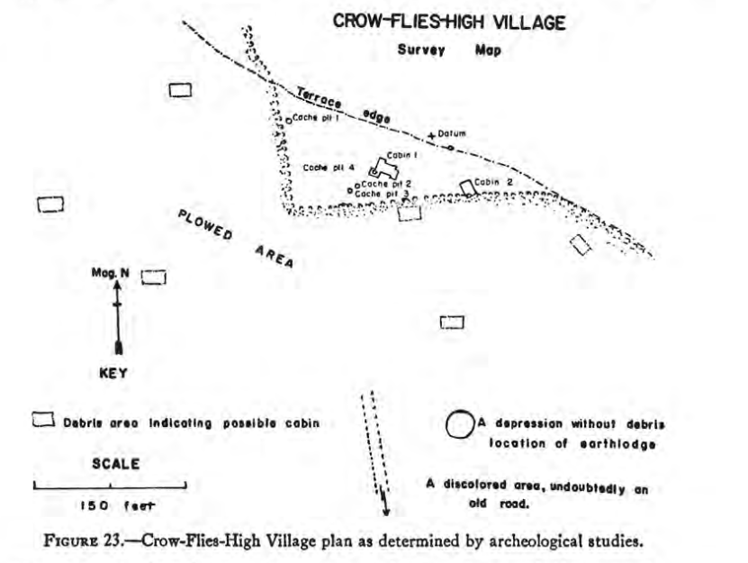
Figure 1: "Crow-Flies-High Village plan as determined by archeological studies," (Malouf 1963:147)

Unfortunately, in 1952, Malouf was only able to locate two cabins and a few cache pits that were undisturbed by plowing (Fig. 1) (Malouf 1963:142). However, after examining the different densities of surface artifacts scattered around the site, he was able to map where he believed cabins were located (Malouf 1963:149). His map was supported by a later map drawn by Bear-In-The-Water or Adlai Stevenson (Fig. 2), a former resident of the village (Malouf 1963:149). There was one earthlodge, which Malouf noted “had been so badly disturbed that excavation was regarded as fruitless” (Malouf 1963:147).
The village was oriented on an east-west axis, and cabins formed a semi-circle around the central earthlodge, leaving space for a plaza (Fig. 2). The dwellings were located on the terrace above the Missouri, and there were gardens one mile north in the bottomlands along the Missouri and a half-mile south around Antelope Creek (Malouf 1963:149).
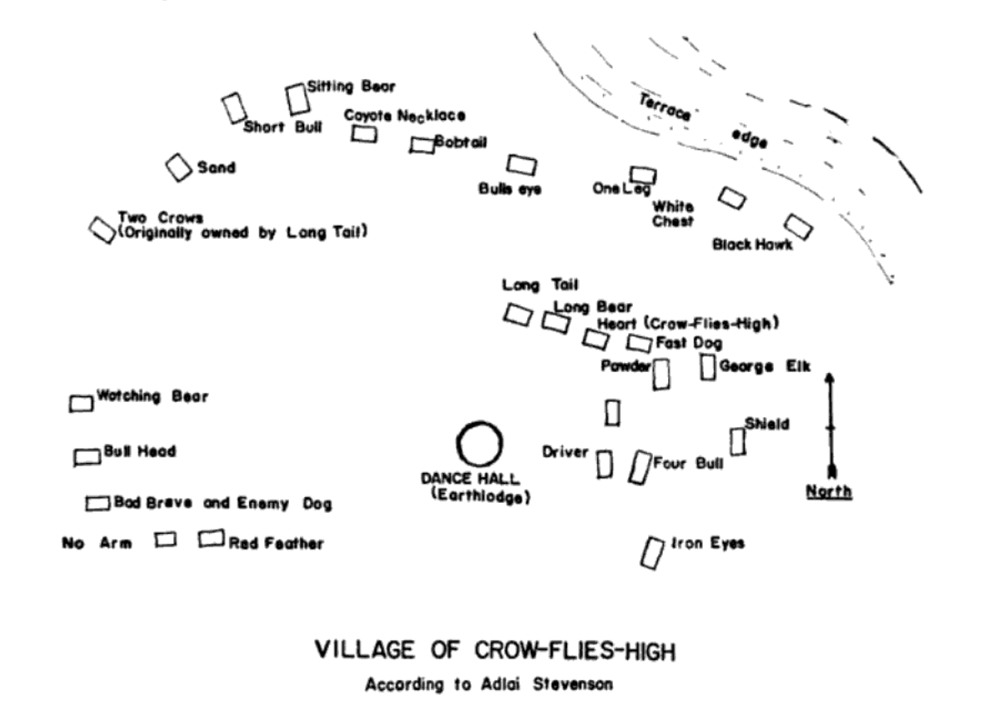
Figure 2: "Village of Crow-Flies-High according to a Hidatsa occupant, and informant, Adlai Stevenson, or Bear-In-The-Water." (Malouf 1963:149)

The excavated materials from Crow-Flies-High Village are located at the University of Montana’s Anthropological Collection Facility in Missoula, Montana. I am incredibly grateful for the access granted to me. I was disappointed but not surprised to find that Malouf’s field notes were not among the documents housed at the University of Montana, but I suspect they may be at the Smithsonian’s National Anthropological Archives, which I was unable to access due to COVID-19 closures.
In total there were over 1400 artifacts; around half were faunal materials, the rest were comprised of lithics, ceramics, glass, leather, and metal objects (See Table 1 and Figure 3 for data summary). A few items were not counted in this summarization, including samples of bison hair, bones too fragmentary to count, metal pieces too fragmentary to count, soil samples, and wood samples.
Figure 3: Data summarization by artifact type
Artifact Type | Count | Percent of Total
Lithics | 119 | 8%
Faunal | 728 | 52%
Ceramics | 52 | 4%
Glass | 174 | 12%
Beads | 71 | 5%
Buttons | 12 | 1%
Leather | 28 | 2%
Metal | 228 | 16%
Figure 3: Data summarization by artifact type
Table 1: Data summarization by artifact type

Only 340 artifacts had explicit provenience information written on tags associated with them, and 174 lacked a catalog number. But the missing catalog numbers were irrelevant because there was no catalog explaining the numbers, the artifacts, and their contexts (hopefully the Smithsonian has this information). Regardless, Malouf’s report mentions artifacts within excavation areas, and from these descriptions, I was able to place quite a few objects into specific locations.
Due to time constraints, I will only focus on a few artifacts types that Malouf did not include and misinterpreted. I also analyze faunal remains that were not elaborated on but are representative of enduring Native social networks and food. Finally, I consider the site’s spatial arrangement and location within the Hidatsa world, something Malouf describes, but does not consider deeply.
What’s Missing and What was Missed
The most egregious thing Malouf did was omit information from his report. That information was the presence of seventy Plains Village pot sherds. Malouf actually states: “No pottery from either the prehistoric level, or the historical Hidatsa was found here. The Hidatsa by this time discontinued pottery making” (Malouf 1963:141). Whether Malouf willingly excluded the sherds from his analysis is unclear, but regardless, they complicate his analysis, which may have factored in their omission.
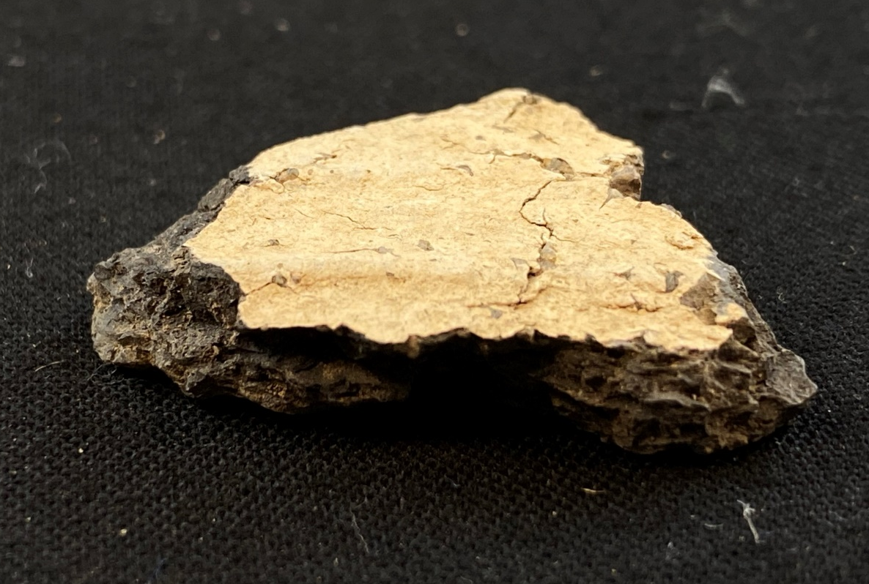
Unfortunately, the sherds were too fragmentary to visually determine their wares. Based on visual analysis alone, a few exhibited simple stamped decoration, and there was a wide range of colors, with the majority being dark brown or gray, a few oxidized sherds (unknown at this time if this is due to paste or clay oxidation), and a few buff. Additionally, 4 rims were present, but they lacked the distinctive elements that could differentiate them as straight or S-rims.
Figure 4: Close up of simple stamped buff sherd
.

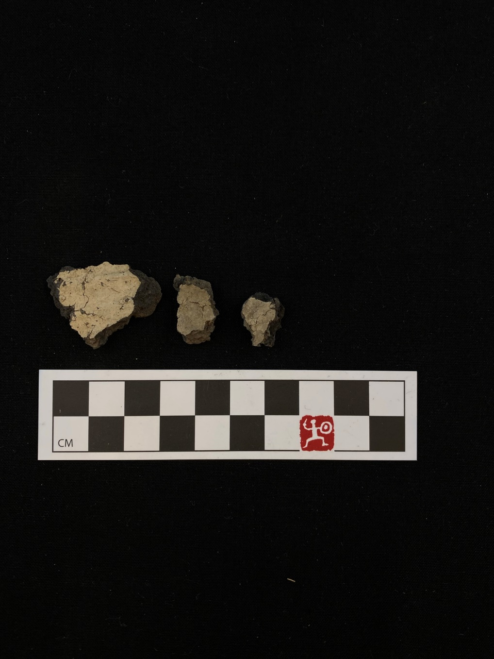
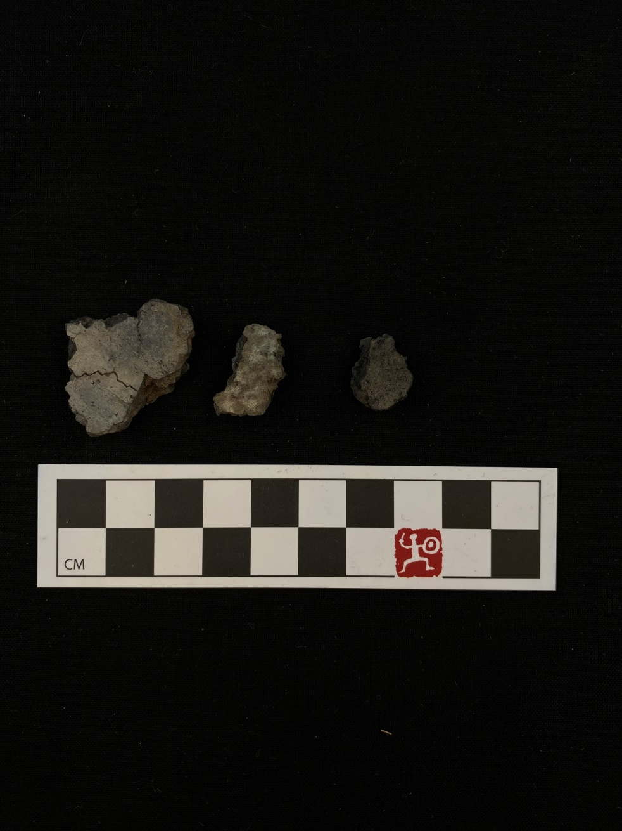

Figure 5: Sherd from Figure 4 alongside two others from same bag

Due to the small size of the sherds and my unpreparedness and therefore inability to conduct detailed ceramic analyses during my visit to Montana, I am unable to draw firm conclusions about these sherds. However, ceramics from contemporary sites such as Like-A-Fishhook, are known to have been poorly compacted with larger pieces of temper and low firing temperatures (Hollenback 2012). The sherds found at Crow-Flies-High Village are better compacted and have smaller temper, some even resemble pre-1837 epidemic vessels. Therefore, though I cannot conclusively say, the sherds may pre-date the occupation of Crow-Flies-High Village.
Because the sherds appear to be older, and there was no evidence of pottery making at the site, I propose these sherds are from vessels that were possibly passed down generationally, like heirlooms, or acquired when visiting traditional sites and brought to the village (see Silliman 2003).
This speculation is inspired by Stephen Silliman’s work among the Eastern Pequot (Silliman 2003). To briefly summarize, Middle Woodland projectile points were found amongst 19th century material on the Eastern Pequot reservation (Silliman 2003:221-224). Because the points were found within an undisturbed context within a lived 19th century space, the “simple notion of change and continuity” was turned on its head (Silliman 2003:224). Their presence could not be dismissed by archaeologists or forced to fit into a change/continuity framework; archaeologists had to think critically about these finds in their contexts (Silliman 2003). He hypothesized that possibly, “these items were reincorporated into Eastern Pequot practices that summoned deeper social memories and that brought them back into discourse and visibility (Silliman 2003: 224).
If these sherds were indeed collected from earlier sites or passed down, their presence at Crow-Flies-High are a possible example of reincorporation and social memory. Unfortunately, without provenience information there is no way to confirm the context of these sherds. If some sherds were found in an undisturbed context, inside one of the cabins, and surrounded by metal objects, it would make my speculation more compelling. Luckily, Malouf also found a significant amount of lithic materials, some of which were found inside cabins, that can be reevaluated in a similar manner.
The majority of lithic materials either had no provenience or were surface finds which Malouf deemed “evidently from a prehistoric level.” In this instance he is likely correct, the various flakes and two projectile points were churned up along with other artifacts when the site was plowed by farmers (Malouf 1963). His other claim about the surface finds: “evidently the location of the village had been a favorite occupation ground in prehistoric times,” which is made solely on the presence of Knife River Flint and the abundance of lithics, is less convincing. More oral historical work about Hidatsa and Mandan use of the area need to be examined in order to confirm this suspicion (Malouf 1963:141).
However, a few of the lithic artifacts were found inside one of the cabins and two of the cache pits: Cabin 1, Cache 2, and Cache 4. Malouf makes several confusing and sometimes contradictory statements throughout the report about possible disturbances to the cabins and caches. Overall it seems that the excavation took place in an unplowed area, but there was come evidence for looters, especially in Cabin 1 (Malouf 1963:142, 146).
The amount of disturbance cannot be evaluated without Malouf’s notes, so the majority of the analyses that follow are speculative and based on assumptions. To begin, a large patinated flake of Knife River Flint was found in Cabin 1 Level 2. In the ‘burned area in the southside of the southeast wing of Cabin 1,’ five large flakes of heavily patinated Knife River Flint were found. In Cache 2, rocks were said to have been laid atop “a cover [that] had been placed in the neck,” beneath the cover, there was evidence of a fire due to oxidized earth, and a partially dismembered calf (Malouf 1963: 146). The only rocks that were specifically provenienced by their tags to Cache 2 were an incredibly smooth river rock and a piece of sandstone. The river rock resembles burnishing stones and whetstones, both used by women in the creation of traditional pottery and hide preparation (Gilman and Schneider 1987).
Finally, the most compelling find was a broken projectile point in Cache 4 amongst porcelain doll legs, white, blue, and red glass beads, and tin cans. This prompted Malouf to conclude: “The single projectile point in the midst of such recent material must have come from an older occupational level through which the pit had been dug” (Malouf 1963:146). Again, without Malouf’s fieldnotes, there is no way to confirm the context of these lithics. However, his immediate dismissal “runs the risk of swamping the complexity of the context and the historicity of material practices and misrepresenting the nature of cultural traditions, persistence, and survival” (Silliman 2003:222).

Faunal Remains
Malouf offers little to no consideration on the enormous amount of faunal remains, including one complete calf and another nearly-complete calf found in the bottom of Caches 1 and 2 (Malouf 1963:144-146). Both had wood beneath them, so they were found resting slightly above the floor of the bell-shaped pits (Malouf 1963:144-146). The cow found in Cache 1 was “a large calf, complete and unbutchered,” and “a heavy green canvas had been wrapped around the animal before it was deposited” (Malouf 1963:144). From the way the bones were positioned he concluded that the pit filled with earth after the community was forcibly removed, and that it took quite a long time to fill with dirt (Malouf 1963:144).
Cache 2 contained “a skeleton of a partially dismembered calf,” but that is all he mentions (Malouf 1963:146). From the faunal remains with provenience information, I was able to discern that the majority of the Cache 2 calf is present, but it is notably missing its skull. Additionally, Malouf does not mention this in his report, but there was an incredibly fragile bison horn with a tag indicating it was found on the surface of Cache 2. By surface it is unclear if it meant the ground surface or the occupational surface approximately one foot below. The horn and a few samples of hair were the only evidence of bison in the excavated materials, but their presence, despite the near extinction of bison in this area in the early 1880s, demonstrates the continued importance of bison in Mandan and Hidatsa lives.
These calf burials are intriguing, and similar burials of bison in cache pits have been noted at the protohistoric sites of Menoken (32BL2), occupied by the Hidatsa between 1400-1700 AD, (Personal communication) and Greenshield (32OL17), first established by the Mandan, but taken over by the Arikara in the 1790s (Nicholas and Johnson 1986). Site reports for Menoken are not readily accessible, but I was able to locate a report from an excavation conducted at Greenshield (Nicholas and Johnson 1986). The report describes:
“A partially articulated bison skeleton was near the floor of Feature 1, the bell-shaped pit in Test 2… The entire mass rested on several large branches or small logs, laid on or near the floor of the pit…It is hypothesized that the legs were removed by the Indians to facilitate placing the animal in the pit… The rationale for interring the bison may be that the occupants of the site shared the Mandan fondness for ‘aged meat.’” (Nicholas and Johnson 1986:196)
Malouf is positive the calf in Cache 1 was placed in the cache where it then decomposed due to the presence of maggot larvae and no signs of butchering (Malouf 1963:144). The cow remains from Cache 2 showed no signs of burning, indicating the fire in Cache 2 which oxidized the soil must have taken place before the calf was deposited. This supports the idea that the cows were placed in the caches while ‘raw,’ possibly indicating a practice similar to that of the Greenshield burial regarding a preference for aged meat.
Furthermore, the presence of cattle at the site itself indicate ongoing trade relationships, most likely with kin and clan members on the reservation. Residents of Fort Berthold were given cattle in 1891, and though it is unclear whether the Crow-Flies-High Village received annuities and rations that included cattle from the Office of Indian Affairs or through members of social networks, calves were present at the site (Felter 1972:81). Additionally, if the burials at Crow-Flies-High, are in fact evidence of aging meat, this may indicate the continuance of traditional food preparation methods indicative of social memory and survivance.
Malouf does not mention anything about potential areas for cattle grazing near the site, so the likelihood of the community pursuing ranching is unlikely, which supports the idea of calves acquired through social networks. The cattle were obtained specifically by the Indian Agent for ranching and selling, and by acquiring cattle, but using them for other purposes like the making of aged meat, can be interpreted as an act of futurity. To explain, the futures the Crow-Flies-High community envisioned for themselves were not the same as what was imagined for them by the Indian Agent. The cow burials indicate that before their removal and return to the reservation, they were incorporating new source material into a past practice; both a reference to the past and to an anticipated new future without bison, making do with cattle.
The Village Layout and Location
Though Malouf notes the spatial layout of the village itself, he dismisses the connections to earlier sites on the basis of Euro-American style cabins instead of traditional lodges. And though he does a good job describing the site, the report lacks deeper analysis of spatial meanings.
As mentioned above in my discussion of residence, the deliberate planning and organization of a community can serve as a reflection of how the community sees themself and their place within the larger world (Preucel 2000). Mandan life is very much centered around their most sacred ceremony, the Okipa, which takes place annually in the summer (Bowers 2004). For example, Mandan earthlodges circled around a central plaza: lodges of families “intimately connected with the Okipa ceremony selected lodge sites adjacent to the open circle,” while the rest radiated outwards (Bowers 2004:25). Clans within Mandan villages were split between east and west moieties, which directly reflected where the clans would sit during the Okipa (Bowers 2004:29). The Hidatsa are not known to have central ceremonial lodges or plazas within their villages (Bowers 1992). Instead, they appointed “four ‘protectors of the people’ representing the four sacred directions” (Bowers 1992:275).
Crow-Flies-High Village’s plaza and central lodge are obvious from the map, but he relationship between the clustering of the houses is less obvious. The densest cluster of cabins is the cluster containing Crow-Flies-High’s cabin, and this cluster is very close to the central lodge. The proximity to the central lodge and plaza could reflect the earlier Mandan organization of important religious figures, who were often sociopolitical leaders as well, that lived immediately adjacent to the central lodge while everyone else radiated outwards.
From oral histories, we know the central lodge was built by the community as a whole and supervised by the Grass Dance Society (Barthelemy 2016). The Grass Dance Society were responsible for its maintenance, since they had purchased the rights to the Grass Dance either from residents of Like-A-Fishhook who had bought it from the Santee Sioux, or directly from the Santee Sioux (Barthelemy 2016). Regardless, the Okipa ceremony and the Sun Dance were both vehemently persecuted during this time, so the Grass Dance, a warrior’s dance, may have represented a compromise (Barthelemy 2016; Gilman and Schneider 1987).
Artifacts supporting the importance of the Grass Dance to members of the community at Crow-Flies-High Village include sleigh bells found at the site. Wolf Chief, a resident of Like-A-Fishhook, described the outfits worn by Grass Dancers: “The outfits consisted of head dresses, sleigh bells for the garters, otter skins for the head, armlets of bead work, yarn belts, and the like” (Wilson 1914:83). The four sleigh bells were unprovenienced, but three of the four appear to be machine-stamped, a technology not widespread until the mid-to-late 1870s (Gilman and Schneider 1987).
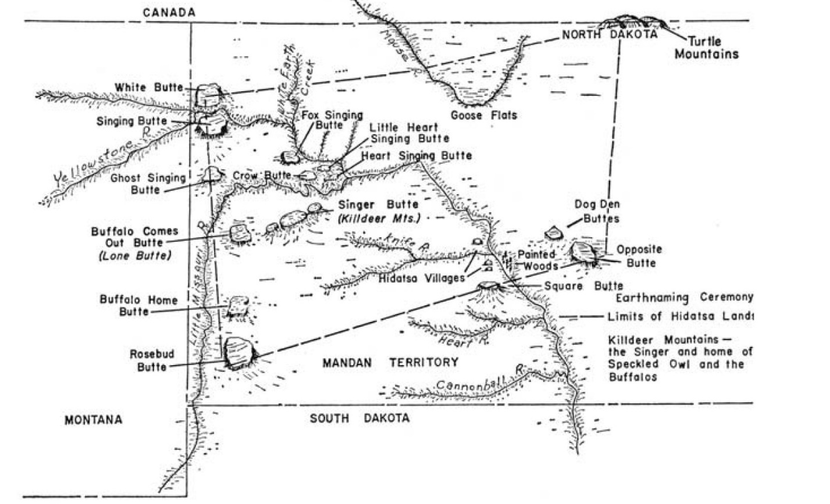
In addition to the village’s internal layout, its positioning within the MHA world is incredibly important. First and foremost, the site, including sites on the reservation, are all within the traditional Hidatsa homeland outlined by the Earthnaming bundle (Fig. 6), the most sacred Hidatsa bundle (Barthelemy 2016:39). Crow-Flies-High Village itself is located within traditional eagle-trapping territory (Barthelemy 2016). Malouf mentions that there are various eagle-trapping pits close by but does not give these any further thought (Malouf 1963).
Figure 6: The Hidatsa homeland and important landmarks outlined in the Earthnaming bundle. Represented by the red dots—from east to west—are the sites Badlands Village, Stream of the Badlands Band, and Like-A-Fishhook Village. Encircled in red is Bah-heesh (Singing Hills)
For both the Hidatsa and Mandan, eagle-trapping was a right obtained by bundle ownership, which passed from father to son, and traditional camp areas were maintained through family lines (Barthelemy 2016; Wilson 1928). The importance of eagles to Mandan, Hidatsa, and Arikara cosmology cannot be understated; they were one of the most sacred animals, equal to buffalo, and were gods of thunder and lightning (Barthelemy 2016). They assisted women in their gardens and had the power to bring rain (Barthelemy 2016). The village is incredibly close to the mythical Brown Bear site of Thunder Butte Trapping Camp, the fifth of seven Black and Brown Bear eagle pits, established when they caught eagles before passing that knowledge to humans (Barthelemy 2016:63; Bowers 1992:215).
Also, of great importance are the Killdeer Mountains, where Ba-heesh, or the Singing Hills, (see Fig. 6 and 7) the center of the Hidatsa cosmos, were located (Barthelemy 2016:39). The Fort Berthold reservation was cut off from the Singing Hills in 1880 when the land outlined in the 1870 executive order containing the Killdeer Mountains was sold to the Northern Pacific Railroad without consent (Barthelemy 2016; Felter 1972:30; Senate Committee on Indian Affairs 1870:883). Around this same time, traditional religious practices, especially those that involved self-marring, like vision quests, the Okipa and Sun Dance, and eagle trapping, were strongly discouraged by missionaries on the reservation and in some instances outlawed (Barthelemy 2016:87). Unlike those living on the reservation, the Crow-Flies-High community did not experience the surveillance or accessibility problems to the same extent. Indicating that like all Native villages in this region, the chosen location of Crow-Flies-High Village was strategic: just close enough to the reservation to visit their families but far enough away from regulation and situated near the center of the Hidatsa cosmos. All of this is missed in Malouf’s report.

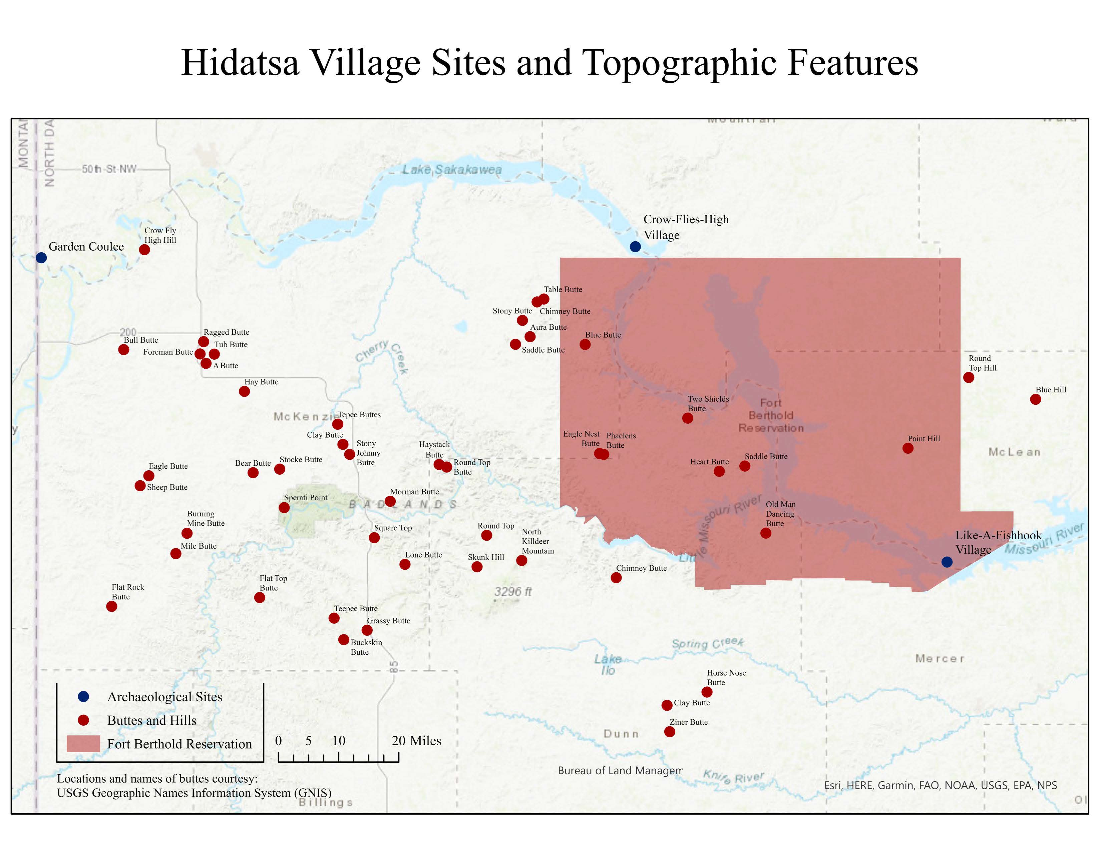
Figure 7: Map showing important topographic features listed in the USGS Board on Geographic Names - Geographic Names Information System (GNIS); estimated locations of the archaeological sites on a contemporary map; and the present borders of the Fort Berthold Reservation.

DISCUSSION
Malouf’s main pitfalls are due to his uncritical acceptance of historical sources—both contemporary and later ethnographic sources—as fact, and then the privileging of ethnographic sources over informants. He noted discontinuities between the ethnographic and informant narratives but had no thoughts about why they might not match (i.e. why an ethnographer would say something different than what an elder would say and why).
He also approached the excavation with a very settler colonial point of view, examining the archaeological record for change that would demonstrate a loss of Indigeneity (Cipolla 2013:12; Silliman 2009:214). He did this using an acculturative approach, dependent on the designation of ethnicities to objects and comparing ratios of non-Native artifacts to Native ones (Rubertone 2000). Additionally, the baselines for his comparisons were early contact and prehistoric sites, which, when compared to a 19th century site, will exhibit considerable differences. In doing this, archaeologists, like Malouf, fail to consider the different processes of colonialism and settler colonialism by condensing the entire historic period, a time span of hundreds of years, into a single phase, and therefore assuming all sites are comparable.
CONCLUSION
In this paper I demonstrated how approaching old archaeological work with new ideas and theoretical frameworks can provide a far more nuanced view of the past. Though the majority of my analyses are speculative at best, speculation allows for complexity, a multiplicity of voices, and breaks free from the settler colonial biases that encourage dismissal and strict categorization.
The Crow-Flies-High Village report is just one of many River Basin Survey reports that remain fundamental to the historic archaeology of the Plains and often remain unquestioned. However, they must be questioned. Archaeological writing has serious consequences for the present, and it is a disservice to descendent communities who lost their heritage to the Garrison Dam, when all that is left is a report like Malouf’s.
We must consider how settler colonialism benefitted salvage archaeology and how salvage archaeology benefitted the settler colonial objective. Additionally, historical archaeology on the Plains, especially from the mid-19th century on, must consider settler colonialism’s processes and effects on the Native inhabitants of this area. Failing to consider the settler colonial impact on Indigenous peoples makes it far too easy to dismiss change as assimilation instead of change as evidence of survivance, residence, practice, memory, and futurity.
Ideally, future research on the site will include analysis of Malouf’s fieldnotes to hopefully glean more provenience information and context for the artifacts. Additionally, a reexamination of Garden Coulee’s materials is necessary to paint a full picture of life among the Crow-Flies-High community. And finally, more collaboration is necessary. I will be honest, a multitude of factors contributed to my lack of collaboration with the MHA community and Michael Barthelemy Jr., but they are all excuses. Moving forward, I will prioritize collaboration and communication.
ACKNOWLEDGEMENTS:
I’d like to thank the University of Montana Anthropological Collections Facility, and especially their Curator, C. Riley Auge', Ph.D. Without the access none of this would be possible. I’m also forever grateful to Kacy Hollenback for mentoring me and pointing me toward the direction of this project, I could not have done this research without you.

REFERENCES
Asad, Talal
1979 “Anthropology and the Colonial Encounter.” In Politics of Anthropology: From Colonialism and Sexism Toward a View from Below, pp. 85-97. The Hague: Mouton.
Asch, Michael
2007 Governmentality, State Culture, and Indigenous Rights. Anthropologica 49(2): 281-284.
Baker, Gerard
2014 “The Missouri River: The Backbone to Survival.” In Dam Projects and the Growth of American Archaeology: The River Basin Surveys and the Interagency Archaeological Salvage Program, edited by Kimball M. Banks and Job Czaplicki, pp. 202-213. Left Coast Press.
Banks, Kimball M., J. Signe Snortland, and Jon Czaplicki
2011 The Price We’ve Paid: From Salvage Archaeology to Cultural Resource Management and Beyond in the Missouri River Basin. Plains Anthropologist 56(220): 371-385.
Barthelemy, Michael Jr.
2016 Hushgah Adiish The Badlands Lodge: A Hidatsa Cultural Hub on the Upper-Missouri River in the Late Nineteenth Century. Masters Thesis, History Department, University of New Mexico, Albuquerque, New Mexico.
Biolsi, Thomas
2018 Power and Progress on the Prairie: Governing People on Rosebud Reservation. University of Minnesota Press, Minneapolis.
Bowers, Alfred W.
1992 Hidatsa Social and Ceremonial Organization. University of Nebraska Press, Lincoln, Nebraska.
2004 Mandan Social and Ceremonial Organization. Lincoln: University of Nebraska Press.
Cipolla, Craig N.
2013 Native American Historical Archaeology and the Trope of Authenticity. Historical Archaeology 47(3): 12-22.
Cipolla, Craig N., Stephen W. Silliman, and David B. Landon
2007 ‘Making Do’: Nineteenth-Century Subsistence Practices on the Eastern Pequot Reservation. Northeast Anthropology 74: 41-64.
Den Ouden, Amy E.
2005 Beyond Conquest: Native Peoples and the Struggle for History in New England. University of Nebraska Press, Lincoln.
Felter, Paul
1972 Fort Berthold Indian Reservation: A Land Use Study to 1971. Master’s thesis, University of North Dakota, Grand Forks, North Dakota.
Fixico, Donald Lee
1990 Termination and Relocation: Federal Indian Policy, 1945-1960. Albuquerque: University of New Mexico Press.
Fox, Gregory L.
1988 A Late Nineteenth Century Village of a Band of Dissident Hidatsa: The Garden Coulee Site (32WI18). Lincoln: J & L Reprint Co.
Gilman, Carolyn and Mary Jane Schneider
1987 The Way to Independence: Memories of A Hidatsa Family 1840-1920. St. Paul: Minnesota Historical Society Press.
Gordon, Greg
2011 Steamboats, Woodhawks, and War on the Upper Missouri River. Montana The Magazine of Western History 61(2): 30-46.
Govaerts, Lotte E
2016 Transformative Consequences of the Garrison Dam: Land, Peoples, and the Practice of Archaeology. Great Plains Quarterly 36(4): 281-307.
Hollenback, Kacy L.
2012 Disaster, Technology, and Community: Measuring Responses to Smallpox Epidemics in Historic Hidatsa Villages, North Dakota. Ph.D. Dissertation, Department of Anthropology, University of Arizona.
Lees, William B.
2014 “Missouri Basin Projects and the Emergence of Historical Archaeology on the Great Plains.” In Dam Projects and the Growth of American Archaeology: The River Basin Surveys and the Interagency Archaeological Salvage Program, edited by Kimball M. Banks and Job Czaplicki, pp. 151-156. Left Coast Press.
Lehmer, Donald J.
1971 Introduction to Middle Missouri Archaeology. Washington DC: National Park Service, U.S. Dept. of the Interior.
Li, Tania Murray
2007 Governmentality. Anthropologica 49(2): 275-281.
Malouf, Carling
1963 River Basin Survey Papers, No. 29: Crow-Flies-High (32MZ1), A Historic Hidatsa Village in the Garrison Reservoir Area, North Dakota. Washington DC: Bureau of American Ethnology Bulletin 185.
Metcalf, G.
1963 River Basin Survey Papers, No. 27: Star Village: a Fortified Historic Arikara Site in Mercer County, North Dakota. Washington DC: Bureau of American Ethnology Bulletin, 182.
Murray, Wendi Field
2011 Feathers, Fasting, and the Eagle Complex: A Contemporary Analysis of the Eagle as a Cultural Resource in the Northern Plains. Plains Anthropologist, 56(218): 143-153.
Murray, Wendi Field and Brad KuuNUx TreeRIt Kroupa
2018 Remembering Nishu: Spatiality and Belonging in the Missouri River Bottomlands. Ethnohistory 65(2): 215-246.
Murray, Wendi Field, Maria Nieves Zedeno, Kacy L. Hollenback, Calvin Grinnell, and Elgin Crows Breast
2011 The Remaking of Sakakawea: Locating Cultural Viability in Negative Heritage on the Missouri River. American Ethnologist 38(3): 468-483.
Preucel, Robert W.
2000 “Making Pueblo Communities: Architectural Discourse at Kotyiti, New Mexico.” In Archaeology of Communities: A New World Perspective, edited by Marcello A. Canuto and Jason Yaeger, 58-77. London: Routledge.
Rubertone, Patricia E.
2000 The Historical Archaeology of Native Americans. Annual Review of Anthropology 29:425-446.
2012 “Archaeologies of Colonialism in Unexpected Times and Unexpected Places.” In Decolonizing Indigenous Histories: Exploring Prehistoric/Colonial Transitions in Archaeology, edited by Maxine Oland, Siobhan M. Hart, and Liam Frink. Tucson: University of Arizona Press.
Senate Committee on Indian Affairs
1870 Statutes, Executive Orders, pp. 883.
Silliman, Stephen W.
2005 Culture Contact or Colonialism? Challenges in the Archaeology of Native North America. American Antiquity 70(1): 55-74.
2009 Change and Continuity, Practice and Memory: Native American Persistence in Colonial New England. American Antiquity 74(2): 211-230.
2010 Indigenous Traces in Colonial Spaces: Archaeologies of Ambiguity, Origin, and Practice. Journal of Social Archaeology 10(1): 25-58.
2014 “Archaeologies of Indigenous Survivance and Residence: Navigating Colonial and Scholarly Dualities.” In Rethinking Colonial Pasts through Archaeology, edited by Neal Ferris, Rodney Harrison, and Michael V. Wilcox. Oxford: Oxford University Press.
Simpson, Audra
2007 On Ethnographic Refusal: Indigeneity, ‘Voice’ and Colonial Citizenship. Junctures: The Journal for Thematic Dialogue 9:67-80.
2018 “Why White People Love Franz Boas; or, The Grammar of Indigenous Dispossession.” In Indigenous Visions: Rediscovering the World of Franz Boas, edited by N. Blackhawk and I. L. Wilner, pp. 166-181. New Haven: Yale University Press.
Smith, Hubert G.
1972 Like-a-Fishhook Village and Fort Berthold, Garrison Reservoir, North Dakota. Washington DC: National Park Service, U.S. Dept. of the Interior.
Trouillot, Michel-Rolph
1991 “Anthropology and the Savage Slot: The Poetics and Politics od Otherness.” In Recapturing Anthropology, edited by Richard Fox, pp. 17-44. Santa Fe: School of American Research Press.
1995 “An Unthinkable History.” In Silencing the Past: Power and the Production of History. Boston: Beacon Press.
Veracini, Lorenzo
2011 Introducing Settler Colonial Studies. Settler Colonial Studies 1(1): 1-12.
Voss, Barbara
2018 The Archaeology of Precarious Lives: Chinese Railroad Workers in Nineteenth-Century North America. Current Anthropology 59(3): 287-301.
Wilson, Gilbert L. (Translator)
1914 Goodbird the Indian: His Story, Told by Himself to Gilbert L. Wilson. Fleming H. Revell, New York.
1928 Hidatsa Eagle Trapping. Anthropological Papers of the American Museum of Natural History XXX(IV): 99-245.

